The Lost Language of Elyam
THE LOST LANGUAGE OF ELYAM, lòèndèd ifeshi Alléèa Ulúddersóadd Lilùslàefs, 557 PP. gadar 2009.
:::
THE LOST LANGUAGE OS ELYAM, printed by Alléèa Ulúddersóadd Lilùslàefs, 557 PP. year 2009.

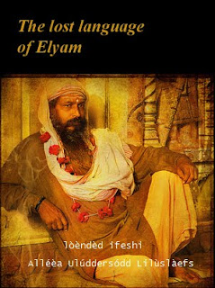

Wès idda s'list wéep szir nerek fudd s'lánslóaslà ladd Elyam, jìmlòèsóng aeon slàemler, aeon éawér, dèksts id wèkdiolìry fudd s'anjíent lánslóaslà ladd Elyam (elyamit vaj elyami) , sdill smáslín raedd s'báren dallày ifeshi sòlé 45,000 fròaslír.
:::
This is the most deep [szir] [work (or some variant of that)] on the language of Elyam, comprising a grammar, a reader, texts and dictionary on the ancient language of Elyam (elyamit or elyami) , still spoken in the báren valley by some 45,000 speakers.
by Ayndryl on Monday, December 07, 2009
Labels Ahaddi , Drizza , Elyam , Semitica , Unknown

